Project title: Promotion of natural and cultural heritage to develop sustainable tourism in protected areas; Ref. no. 842
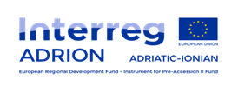
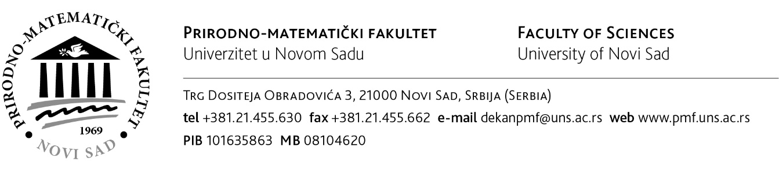

Procurement procedure – Services related to preparation of the Communication plan, PR and Press Conferences and Design and Printing services of promotional materials and Final publication for the project PRONACUL
Ref. no. 842-PRONACUL-4/communication, PR, press and printing
Date of starting tender procedure: 07.12.2020.
Potential tenderers can request tender documentation via email jasmina.djordjevic@dgt.uns.ac.rs

