Project title: Promotion of natural and cultural heritage to develop sustainable tourism in protected areas; Ref. no. 842
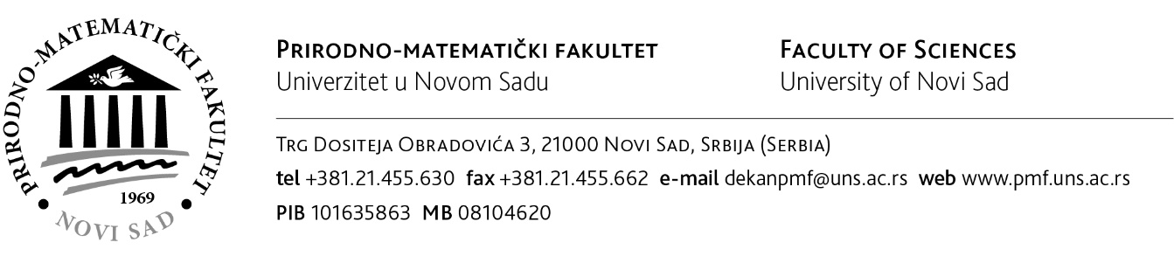
Procurement procedure - Supply of computer with multi-touch screen for the project PRONACUL
Ref. no. 842-PRONACUL-1/IT EQUIPMENT
Date of starting tender procedure: 23.11.2020.
Potential tenderers can request tender documentation via email jasmina.djordjevic@dgt.uns.ac.rs

