8th International Conference on Monitoring and Management of Visitors in Recreational and Protected Areas, Novi Sad, Serbia, September 26-30, 2016

Authors’ instructions for extended abstracts

An extended abstract of maximum 1000 words + one figure or table should be submitted to the conference organizer by May 01 2016, and upon submission adhere to the below guidelines. It is important that your text uses clear and correct English language. We reserve the right to make grammatical and linguistic changes. The extended abstract will be published in the conference proceedings which you will receive upon arrival at the conference.

Save the document in MS Word format using the First and Family name of the presenter, for example john.smith.doc. E-mail the document (and your figure/table) no later than May 01 2016 to: mmv8@dgt.uns.ac.rs

____________________________________________________________________________________________

Title (Arial 16 pt, bold)

Name, affiliation, nationality and e-mail of first author (Times New Roman, italics, 11 pt)
Name, affiliation and nationality of co-author(s) if applicable (Times New Roman, italic, 11 pt)

Main text (Times New Roman, 12 pt, single spaced, maximum 1000 words) Main text (Times New Roman, 12 pt, single spaced, maximum 1000 words) Main text (Times New Roman, 12 pt, single spaced, maximum 1000 words) Main text (Times New Roman, 12 pt, single spaced, maximum 1000 words) Main text (Times New Roman, 12 pt, single spaced, maximum 1000 words) …

Main headline (Arial 14 pt, bold)

Second headline (Arial 12 pt, italic)

Main text (Times New Roman, 12 pt, single spaced, maximum 1000 words) Main text (Times New Roman, 12 pt, single spaced, maximum 1000 words) Main text (Times New Roman, 12 pt, single spaced, maximum 1000 words) Main text (Times New Roman, 12 pt, single spaced, maximum 1000 words) Main text (Times New Roman, 12 pt, single spaced, maximum 1000 words) …

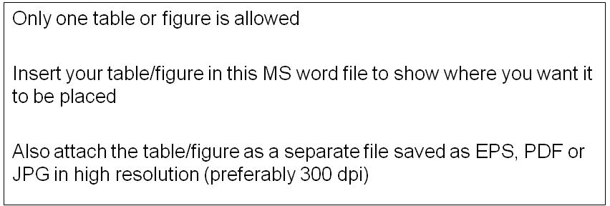

Figure/table captions (Arial 10)

Main text (Times New Roman, 12 pt, single spaced, maximum 1000 words) Main text (Times New Roman, 12 pt, single spaced, maximum 1000 words) Main text (Times New Roman, 12 pt, single spaced, maximum 1000 words) Main text (Times New Roman, 12 pt, single spaced, maximum 1000 words) Main text (Times New Roman, 12 pt, single spaced, maximum 1000 words) …

References (Times New Roman, 10 pt, maximum six references, Harvard system)
References (Times New Roman, 10 pt, maximum six references, Harvard system)
References (Times New Roman, 10 pt, maximum six references, Harvard system)
…

_________________________________________________________________________________

Please do not use end- or footnotes!

