Expression of interest

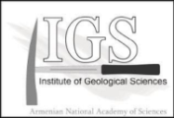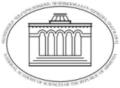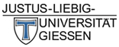

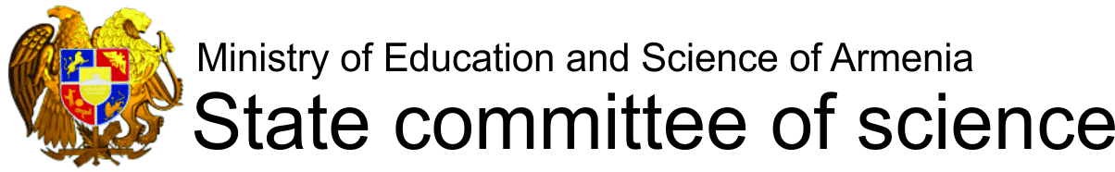

NATIONAL ACADEMY OF SCIENCES OF THE REPUBLIC OF ARMENIA
INSTITUTE OF GEOLOGICAL SCIENCES

Loess Deposits as Archives of Environmental
Change in the Past
International Conference
YEREVAN, ARMENIA, 15-22 September 2019
We kindly ask you to fill out the form in order to support our organizational tasks. Thank you!

First Name:
Second Name:
Country:
E-mail:
Interests:
Please tick (✓)
1. Participation at the conference Yes No
2. Participation in excursions: 2 days Yes No
5 days (2+3 days) Yes No
4. Accompanying person:
(number of people)

Please return this form not later than 31 May 2018 to loess2019@geology.am

