THE EFFECT OF BICYCLE RENTAL SYSTEM "NS BIKE" ON TOURIST OFFER OF NOVI SAD (14pt, bold)

Lukrecija Djeri¹, Predrag Stamenković^{2*}, Bojan Radojević³, Jelena Suleić⁴ (12pt bold)

¹ Department of Geography, Tourism and Hotel Management, Faculty of Sciences, University of Novi Sad, Trg Dositeja Obradovića 3, 21000 Novi Sad, Serbia
² Higher Business school of Vocational Studies in Leskovac, Vlade Jovanovića 8, 16000 Leskovac, Serbia
³ Department of Geography, Tourism and Hotel Management, Faculty of Sciences, University of Novi Sad, Trg Dositeja Obradovića 3, 21000 Novi Sad, Serbia
⁴ University Singidunum, 32 Danijelova St., 11000 Belgrade, Serbia
*Corresponding author: leskopex@yahoo.com (Times New Roman 12pt)

ABSTRACT (Not longer than 350 words)
The number of bikes has significantly increased at the beginning of XIX century, and shortly became widespread. Its low production cost, availability, healthy lifestyle trends and movements for sustainable development during the last decades, helped the bicycle to become the most widespread mean of transport in the world. In order to use the bike in greater numbers and for tourist purposes, it is necessary to ensure the possibility of renting bikes to tourists at tourist destinations. The aim of this paper is to determine the impact of "NS bike" (Bike rental system) on tourist offer in Novi Sad. The results confirmed initial hypothesis that well-designed bike rental system directly affects the differentiation of the tourist offer of Novi Sad and increases the competitiveness of the city as a tourist destination. Bike rental systems in cities around the world are fast growing. Novi Sad became the first city in the Balkans, which has organized a public bicycle rental system on the principle of sharing. The number of users, and rental stations are constantly increasing, and nearly 30% of users are from other parts of Serbia and abroad. The system was primarily designed and developed as an alternative transport system. However it also has a positive impact on the image of Novi Sad as a tourist destination. This system is the most important service provided by "Parking service" company in terms of tourism, and it is a tourist attraction itself, which is already included in the official tourist offer of Novi Sad. (Times New Roman 12pt)

KEY WORDS (Not more than 7 words)
City tourism, bycicle rental, “NS bike“ system

Introduction (Times New Roman 12pt, bold)

According to the space on which a tourist trip takes place, an important place is taken by urban tourism, which in addition to its cultural, also includes other and specific forms of tourism. Since that, without traffic there would be no tourism (except virtual one), there is an irreplaceable and indisputable connection between traffic and tourism. In accordance with the traffic management policy, in cities around the world, attempts are made to reduce the use of passenger vehicles, and the demand for transport is compensated by other means of transport. The effects of reducing the number of cars on the streets are enormous, in the form of more efficient transport, savings, reducing traffic congestion, and reducing environmental pollution. Of course, the most effective way to pull this off is the efficient use of public transport, but also the massive use of bicycles is extremely effective. Based on this, we come to the conclusion that the concept of the development of a transport infrastructure must be based on the view that, priority conditions for use should be provided for pedestrians, cyclists and public transport, and to discourage the car users (Radojević, 2016).
The dominant opinion is that the problem of parking is the problem of a residential population in daily migration, while is perceived only as a secondary tourist problem. Understanding that parking can finally be solved by administrative methods causes the problem that is overstated by extorted solutions. In addition to the parking of passenger cars, PUC "Parking service" Novi Sad is engaged in renting bicycles, removing vehicles, informative-propaganda activities, as well as other services of smaller volume. The assumption is that all these services have a greater or lesser impact on the tourist offer of the city Novi Sad and that, if they are performed well, the quality of the city tourist in general is improved. (Times New Roman 12pt, 1.5 spaced)

Literature review

According to author Hsi-Chang (2003) cycling tourism can be defined as a positive activity that combines the experience of transportation and recreation with the overall tourist experience. The European countries and the United States significantly promote the development of cycling tourism, as well as the use of bicycles as a means of transport in everyday activities of their citizens (Hose, 2000). Since the end of the 20th century, tourism and recreation have become increasingly important in generating the newly created value of national economies, especially in the underdeveloped regions of the world. The relationship between tourism and traffic development is inseparable and has a significant impact on the local economy. Pedestrian and cycling tourism are extremely important in the context of sustainable tourism development.
Bike tourism is also defined as taking a trip using a bicycle or using a bicycle as a primary vehicle for traveling, which can offer bike riders a pleasant travel experience (Ritchie,1998). Many countries, around the globe, propose so-called bicycle-friendly towns. In the year of 1988, European Parliament passed the pedestrian and bicycle rights (Chang, 2004). According to Mapes (2009), the cities with successful bike promotion include Amsterdam (the Netherlands); Copenhagen (Denmark); Paris (France); Davis, Portland, New York and Chicago (U.S.A.) (Chen and Lee, 2017). Creating a bicycle-friendly environment and atmosphere can help boost the bicycle tourism industry. Bike sharing schemes have existed for almost fifty years but only in the last decade have they significantly grown in prevalence and popularity to include over 800 cities across the world and a global fleet exceeding 900,000 bicycles (Meddin, 2015). In their historical development they have progressed through so-called ‘generations’ (Beroud and Anaya, 2012; DeMaio, 2009). Modern 3rd generation of Bike sharing schemes, shares a few new key features (Anaya and Castro, 2012) relating to the application of modern information and communication technologies.

Bicycle Rental System

Renting a bicycle is a way that a person who, currently or permanently, does not have a bicycle to get a bike and satisfy his need for transportation. Bicycle rentals are popular, both in rural and in city tourist destinations. The basic type of renting a bicycle is the "Rent" system, that is, it can be said, "ordinary" bicycle rental. With this rental, a bicycle is rented in one location, usually on a day, and after returning it, it returns to the location where it was leased. This type of bicycle rental is much more popular in the rural tourist destinations (coastal, mountainous and other).
The second type is a rental system of "park and ride". In this type, the driver parks the car at a certain parking lot, then rents a bicycle, or changes the type of transportation. When finished using the bike, driver comes back to his starting location, returning the bike and takes the car. This type of bicycle rental is popular in both urban and rural tourism destinations. "Share" is the third type of bicycle rental. For this type of rent in the territory where bicycles are used, there are several stations. The bicycle can be rented on one, and returned to another station, depending on the needs of the user. This type of rent is more popular in city tourist destinations. It efficiently uses the existing number of bikes, as sharing bicycle times serves to a significantly larger number of users. For this type of rent, which is completely different from the first two types, we say that it is a bike rental system. It can be part of a tourist offer of city tourist destinations, but also a form of public transport.
The specific characteristics of all mentioned types are, rental charge, taking over and returning bicycles (can be manual or automated) and a pricing policy. With regard to ownership, all three types may be in private, public or mixed ownership.

"NS bike" system

Novi Sad has become the first city in the Balkans to have organized a public bicycle rental system "bike sher". In our country, except in Novi Sad, there are later formed bicycle system in Subotica and renting bicycles in Belgrade. Belgrade bicycle rental is a type of "park end ride" so it cannot be compared to Novi Sad. In Belgrade, to the citizens within three locations "Ada", "Sava Center" and "25. May" is provided free of charge bicycles rental, if they park their car in a garage (or at a closed parking lot). On returning a bike, car drivers pay only a regular car parking price in the garage. Therefore, free allocation of bikes is only allowed for garage users within the three listed facilities. There are electric and regular bicycles in the Belgrade rental. Such rent has no significant impact on the tourist offer there.
Subotica, bicycle system is a "bike share" type and is completely similar to the Novi Sad system, except that it is significantly smaller in scope. It covers the territory of Subotica and Palić, where there are five bicycle rental stations and around 60 bicycles in circulation within the system. Subotica and Palić improved the quality of their tourist offer by introducing a bike rental system called "SU bike".
Figure 1. Getting Started "NS bike" rental system in Novi Sad in July 2011 (Times New Roman 12pt)
Source: PUC Archive "Parking Service" (Times New Roman 10pt, italic)

The Novi Sad city government, recognizing traffic problems in the city and the negative consequences of environmental pollution, has set as high-priority tasks an alternative transport and devotion for a healthy environment. The campaign "Let's bring Novi Sad to bikers" was launched in the year of 2009, with the aim of promoting a bicycle as a mean of transport whose massive use would contribute to the reduction of traffic jams and pollution. As part of this action, the project "NS Bike" started in July 2011, on the base of models of developed European cities, Novi Sad has become the first city in the Balkans with an organized network for renting bicycles (Figure 1). Bicycle infrastructure in Novi Sad is quite good, and bicycles are therefore very popular in the local community. Novi Sad maintains and continuously improves the network of biking trails in the implementation of its city traffic policy. Through the city, along the river of Danube, the European cycling route – Euro Velo 6, Atlantic - Black Sea passes. Trails of "tourist" biking trails are mostly planned by existing embankments, ataric and forest roads, but also by existing biking trails in the territory of the City. In support of this infrastructure, in the past years, PUC "Parking Service" has built and arranged safe parking for bicycles, with over 500 parking spaces on several locations in the city.
In order to make Novi Sad more accessible for cycling, in the upcoming period, City will be intensively engaged in marking and arranging bicycle paths and removing cars from bicycle space. Part of the plan is to increase the number of bicycle rental stations, as well as parking and locking stations, opening new bicycle garages and increasing the number of available bicycles.
Figure 2. Cards for using the "NS bike" system
Source: PUC Archive "Parking Service"

The principle of "NS bike" system functioning is the "bike share" type. This means that in a number of locations in the city there are regulated stations where bicycles are parked and locked. The user in the station borrows a bicycle, performs the desired trip, and returns the bike to the station that suits him most. For the service of a bicycle, the user is obliged to pay the appropriate fee in accordance with the pricelist created on the basis of a pricing policy. The rental price is of a stimulating character and is 20 dinars per hour, or 100 dinars for daily use of a bicycle.
User registration is a necessary procedure that is done only for the first time, in order to use the service of the "NS bike" system. The user carries out the registration with personal documents and gets a user card with which he can rent a bicycle in the future. Registration means the signing of the Agreement on renting and making a chip card, which represents a one-time expense of 500 dinars for the user and unlimited duration (Figure 2). The amount of money on the card can be refilled and spent unlimited times. Bicycles in the system are robust, unisex, with branded front and rear wheel protectors, basket and other equipment. There are currently around 130 bicycles in circulation, and it is estimated that the Novi Sad system, based on comparisons with other European cities of similar size in the optimal model, should have around 600 bikes and 60 cells.
Figure 3. Station "NS bike" system "Belgrade Quay" opened in fall 2015.
Source: PUC Archive "Parking Service"

The stations of the "NS bike" system are specially designed (Figure 3). Some are covered with green roofs, and some have a bicycle building wall. An individual station consists of a stand (a bicycle leaving part) and a control cabinet (housing for fitting equipment for semi-automatic controlling by unlocking and locking the bicycles). Depending on the conditions dictated by the location, the booth is constructed with the possibility of one-way or double-sided parking, as well as the possibility of changing capacities (modular type and can be upgraded - continue in length). The basic capacity is 14 units. The stand is divided into boxes that are equipped with a locking and unlocking device and a light signal that is activated when taking or returning a bicycle. The control cabinet is made in the form of a metal enclosure and serves to accommodate equipment for the functioning of the station. The working hours of the stations are 24 hours a day (during the season) and all are covered by video surveillance.

Table 1. Increase in the number of stations "NS bike" system for renting bikes from start up to date (Times New Roman 12pt)
Year | 2011 | 2012 | 2013 | 2014 | 2015 | 2016
Number of stations | 5 | 5 | 8 | 10 | 11 | 12
Source: PUC Archive "Parking Service" Times New Roman 10pt, italic)

The locations of the 12 stations of the "NS bike" system are: Štrand, Spens, Railway Station, Serbian National Theater, Campus of Novi Sad University, Belgrade Quay, Detelinara ABC Center, Detelinara corner of Kornelija Stankovic Street and Milenko Grcic, Liman 3 NIS, Liman 3 Health Center, Novo naselje Bulevard Jovana Ducica near Rodic and Petrovaradin Preradoviceva street, near the post office (Table 1).

Influence of the "NS bike" system on the city's tourist offer

According to data from PUC "Parking service", the number of users of bicycle rental system has exceeded 4 thousand, and the 2015 season was very successful with over 27 thousand leases. In the year of 2016 we notice a drop in the number of leased bikes with a total of 20,582 leases (Figure 4). This is primarily the result of a new way of statistical processing of data and therefore should be considered with reserve. We can conclude that the bicycle rental represents a significant additional, complementary offer to the city tourism of Novi Sad. Therefore, the utility and tourist offerers continuously improve the “NS bike” system and increase the number of stations (the stations of the "NS bike" system) and the number of bikes for rent.
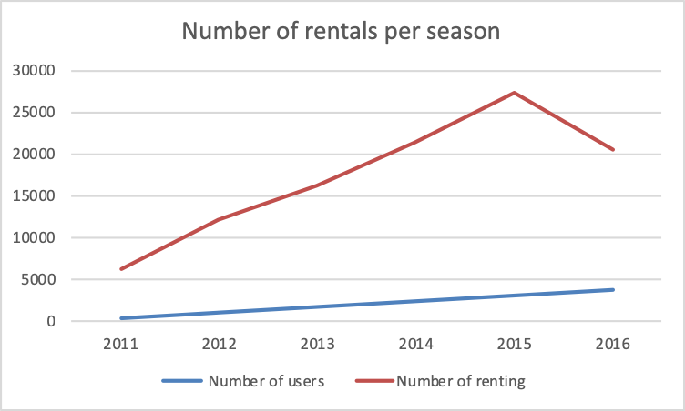
Figure 4. Number of bicycle rentals in "NS bike" system per season, for the period 2011 – 2016. (Times New Roman 12pt)
Source: PUC Archive "Parking Service" (Times New Roman 10pt, italic)

According to the place of residence, the absolute majority of users of the "NS Bike" system are from Novi Sad, but almost 30% are users from other parts of Serbia and abroad. Among the foreigners, the largest percentage was the Russians 1.03%. Foreign tourists from other countries have achieved, each individual percentage below 1% (Germany, Croatia, USA, Bulgaria, Poland, Bosnia and Herzegovina, France, Greece, Italy, etc.). This percentage of beneficiaries - the tourist is very important, but it should be taken with reserve, because it can include also an unregistered residents of Novi Sad (Figure 5).
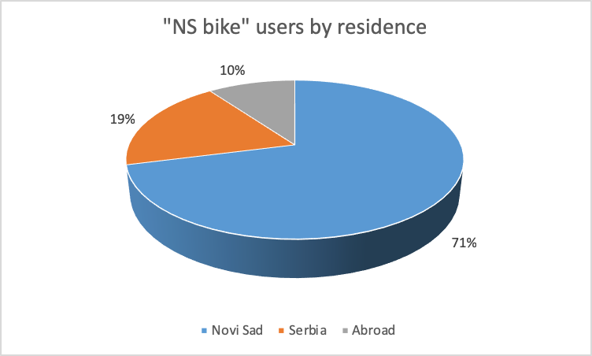
Figure 5. Percentage of "NS bike" system users according to place of residence
Source: PUC Archive "Parking Service"

The bicycle rental system "NS bike" in Novi Sad has a significant impact on the city's tourist offer. It is the most important service of PUC "Parking service" directly in tourist terms. In addition, it is a tourist attraction by itself. As such, it is already included in the official tourist offer of the City. The system has a good website. Information leaflets about the "NS bike" system are shared in the Tourist Information Center of the City, where users could register. Also, in the previous years, leaflets were distributed during the Exit Festival. Visitors to Novi Sad have already become accustomed to "NS bike". Many tourists, because of its existence, opt for a bicycle when visiting and exploring the city, parks, museums and galleries. In cooperation with the Tourist Organization of Novi Sad, the next season plans, are to organize thematic biking tours. In financial sense, "NS bike" system is not profitable, but as a part of the overall traffic policy of the city, ecological and tourist importance is favorable. The "NS bike" system is not without fault in a tourist sense. The system is primarily designed and developed as a system of alternative transport in the city, and not as a tourist attraction and part of the city's offer. It is more focused on daily migration, and less on tourism. Insurance for damage is taken from foreign tourists in the form of a cash deposit. There are few places to register or sell cards (for example, hotels, travel agencies and other legal entities). Due to security while registering a user, a Usage Agreement is signed. It could, with an electronic signature and an appropriate procedure via the Internet, ensure the purchase of the card and the registration on each store. And of course, for the city of Novi Sad needs, "NS bike" system could be larger by number of stations and by number of bikes. Even though it also has small flaws, the "NS bike" system is extremely important for the city of Novi Sad, both for tourism and for the positivity it brings to the PUC "Parking Service" which is also the most important service provided for tourists by this enterprise. It can be said that the "NS bike" system returned to the streets of Novi Sad the culture of riding a bicycle, a smile and a healthy lifestyle.

Conclusion

Services of PUC "Parking service" that have the greatest impact on the tourist offer of Novi Sad are parking of passenger vehicles, "NS bike" system, vehicle removal and information and propaganda activity, and among other services there are parking of buses and bicycles as well as the installation of mobile barriers and stairways to protect pedestrian zones. The overall parking regime in the territory of the urban area is relatively well functioning under the circumstances. Payment methods are simple and convenient, and vulnerable categories of users are favored. Parking lots on the territory of the city center of Novi Sad are well positioned, taking into account acceptable walking distance, to have an adequate parking regime, and to support the activities of tourists. Also, occasional car parks around day-to-day attractions have a good position and parking mode. On the Petrovaradin side of the city, the situation is bad and requires quick action.
The bicycle rental system "NS bike" in Novi Sad has a significant impact on the city's tourist offer. It is the most important service of PUC "Parking service" directly in tourist terms. In addition, it is a tourist attraction by itself. As such, it is already included in the official tourist offer of the City. Even though it also has disadvantages, the "NS bike" system is extremely important for the city of Novi Sad, and in the tourist sense and by the positivity it brings to the image of the city and PUC "Parking Service", it is also the most important service that this company provides. The construction of bicycle parks and the installation of bicycle holders play an important role in improving the functionality of Novi Sad in cyclo-tourism. They represent the basic infrastructure (along the cycling paths) of cyclo-tourism, which is especially important for Novi Sad because of the famous cycling culture, the city bike rental system and the position of the city on the European cycling route.

Acknowledgments

References

Anaya, E., & Castro, A. (2012). Balance General de la Bicicleta Pública en España. Fundación ECA - BUREAU VERITAS. Accessed 15/06/2017, https://bicicletapublica.files.wordpress.com/2013/03/balance-general-de-la-bp-en-espac3b1a.pdf.
Beroud, B., & Anaya, E., (2012). Private interventions in a public service: an analysis of public bicycle schemes. In Parkin, J. (Ed.), Cycling and Sustainability. London: Emerald.
Chang, H. W. (2004). A Study on Development Experience of Recreational Cycling. Urban Traffic. 19(1), 1-10.
Chen, C., & Lee, H., (2017). How to promote bike tourism globally. Tourism and hospitality management, 23(1), 1-16. DOI. 10.20867/thm.23.1.2
DeMaio, P. (2009). Bike-sharing: history, impacts, models of provision, and future. Journal of Public Transportation 12(4), 41-56.
Hose, T. A. (2000). European geotourism-geological interpretation and geoconservation promotion for tourists. Geological heritage: its conservation and management (127-146). Madrid: Instituto Tecnologico Geominero de Espana.
Mapes, J. (2009). Pedaling Revolution: How Cyclists Are Changing American Cities. Oregon: Oregon State University.
Meddin, R. (2015). The Bike Sharing World - 2014 -Year End Data. Accessed 15/06/2017, http://bike-sharing.blogspot.co.uk/2015/01/the-bike-sharing-world-2014-year-end.html.
Radojević, B. (2016). Uticaji usluge JKP „Parking Servis“ na poboljšanje kvaliteta turističke ponude grada Novog Sada. Novi Sad: Univerzitet u Novom Sadu – Prirodno-matematički fakultet.
Ritchie, B. W. (1998). Bicycle tourism in the South Island of New Zealand: Planning and management issues. Tourism Management. 9(6), 567-582. DOI: http://dx.doi.org/10.1016/S0261-5177(98)00063-6.

